Wishes for Our Warriors: Collecting Cozy Comforts
2022 Fall and Winter
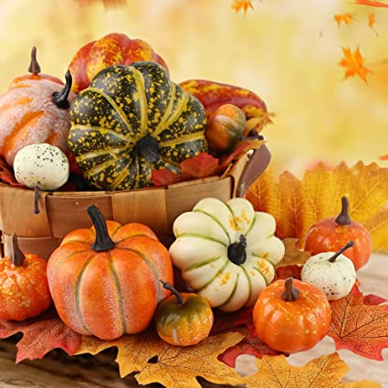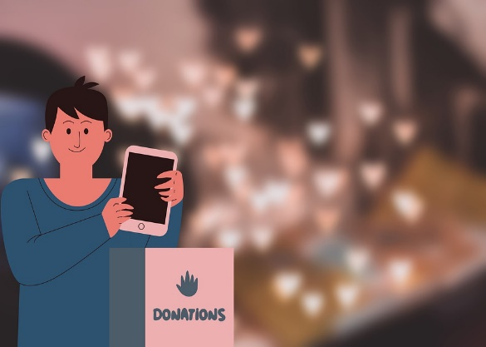
Hi Everyone!
Hope all of you are enjoying these cooler temperatures! We, at Life of Pretty prefer the warm months, but know there are so many out there who need our Warm Wishes, so here we are once again!
Yes, it’s that time of year where many of us are enjoying the time with family and friends, holiday decorations, shopping for loved ones, colder temperatures while we are getting ready for the holidays.
What do the holidays mean to you? What about those out there who aren’t quite as lucky as we are to have a warm home, clothes for every day, food, and the means for a festive holiday season-whatever one might celebrate.
Well, for thousands of men and women out there it means life in a hospital, a country far away from those they love, or somewhere, on the cold streets with or without their families.
So, as many of you know, we, at Life of Pretty have formed Cards for Our Vets, to bring some sunshine and appreciation to some of our area veterans, mainly those at Coatesville VA Medical Center.
With much anticipation, Cards for Our Vets asks all of you to help with our collection of hand-made messages, pictures and cards for these dedicated men and women who have given so much to our country.
This year we thought about stepping up our collection a little bit. We were hoping we could collect like we did last year, gloves, hats, socks, toiletries, and blankets, but it was requested by the shelters that we add dish soap, hand soap, detergent, paper towels and toilet paper for our homeless as well. Even items that you no longer use but are in good shape, please think about donating them. I am sure someone will be truly grateful! If there is something specific you think you would like to add to our collection for them, please feel free.
This time we will be visiting our veterans and homeless right before Christmas, and the card theme for this collection will be With Love Winter. Please help us show our service men and women how much we appreciate them and assure them that they are never forgotten. Not to mention help them stay warm this winter.
Collection day will be December 19th. Feel free to contact me either by email jmckiernanclarke738@gmail.com or phone @ 484-688-6128 to let me know what time and where I can pick them up. As always, our veterans love the cards and donations and anything you provide will be awesome and we appreciate all your help in making this possible!
Warm regards and thanks,
Jeannie McKiernan-Clarke
Cards for Our Vets
Wishes for Our Warriors
PS: Please forward this to anyone else who may be interested in supporting these collections.
